UNIVERSITY OF MACAU

CISC7204 Data Science and Data Visualization
Assignment 02 - Preliminary Project Proposal

PROJECT TITLE:

Global Box Office Success: Comparative Analysis of Production Budgets vs. Public Ratings

Course Code: | CISC7204
Course Title: | Data Science and Data Visualization
Coursework Item: | Assignment 02 - Preliminary Project Proposal
Student Name: | Luo Yawen
Student ID: | MC656094
Submission Date: | 23/10/2026
Global Box Office Success: Comparative Analysis of Production Budgets vs. Public Ratings

Research Focus & Data Foundation

Research Question
In the global film industry, which serves as a stronger predictor of worldwide box office success: production budget or public rating? Specifically, this study investigates the explanatory power of budget and IMDb ratings on revenue, evaluates the correlation between financial scale and audience sentiment, and determines each predictor's marginal effect in a combined model.

Region & Domain
Region: Worldwide (covering multi-country international theatrical releases)
Domain Category: Film Economics, Media Analytics, and Entertainment Data Science

Data Sources
This project combines two Kaggle datasets connecting film financials with audience ratings.
Dataset 1: TMDB 5000 Movie Dataset
Link: https://www.kaggle.com/datasets/tmdb/tmdb-movie-metadata
Description: Provides financial data fields including global theatrical box office revenues, allocated production budgets, original titles, genres, and release dates across thousands of feature films.
Dataset 2: IMDb Top 1000 Movies Dataset
Link: https://www.kaggle.com/datasets/harshitshankhdhar/imdb-dataset-of-top-1000-movies-and-tv-shows
Description: Contains user rating scores, vote counts, meta scores, director credits, and primary cast details sourced directly from the Internet Movie Database.

Project Purpose and Significance

Outcomes
This project aligns with course objectives by integrating TMDb financial metrics and IMDb audience data to analyze commercial film performance. It strengthens my quantitative foundation, refining skills in multi-source data merging, econometric modeling, and data storytelling. These competencies prepare me for data analyst and quantitative consulting roles in entertainment.

Skills
Data Cleaning and Integration: Using Python (Pandas) to normalize movie titles (trimming whitespace, lowercasing) and standardize release years, then merging TMDb and IMDb records via exact matching. The process filters out non-positive budgets or revenues and removes observations missing core variables.
Statistical Modeling and Diagnostics: Calculating Pearson correlation matrices, applying logarithmic transformations to skewed financial variables, fitting univariate and multivariate OLS regressions, and evaluating goodness-of-fit ($R^{2}$, Adjusted $R^{2}$), p-values, and multicollinearity.
Data Visualization: Leveraging Matplotlib and Seaborn to generate distribution plots, boxplots, correlation heatmaps, and regression scatter plots with 95% confidence intervals.

Knowledge
Gaining deeper insight into core data science concepts, including multicollinearity, goodness-of-fit (($R^{2}$), adjusted ($R^{2}$ for model complexity, logarithmic transformations for skewed financial variables, and the interpretation of regression coefficients and p-values.

Experimental Tasks

Task 1: Data Import, Cleaning and Integration
Load TMDb and IMDb datasets, normalize titles (trim whitespace, lowercase), and standardize release years. Merge via exact matching, filter out non-positive budgets or revenues, remove observations missing core variables, and retain Box_Office_Revenue, Production_Budget, and Public_Rating_Score.

Task 2: Descriptive Statistics and Exploratory Data Analysis
Calculate the mean, median, and standard deviation of the three core variables. Plot variable distribution histograms (with KDE curves) and boxplots in a $3×2$ layout to examine skewness, multimodal patterns, and outliers.
 | Box_Office_Revenue (million) | Production_Budget (million) | Public_Rating_Score
Mean | 217.8 | 43.1 | 7.97
Median | 100.7 | 21.5 | 7.90
std | 297.1 | 54.4 | 0.32
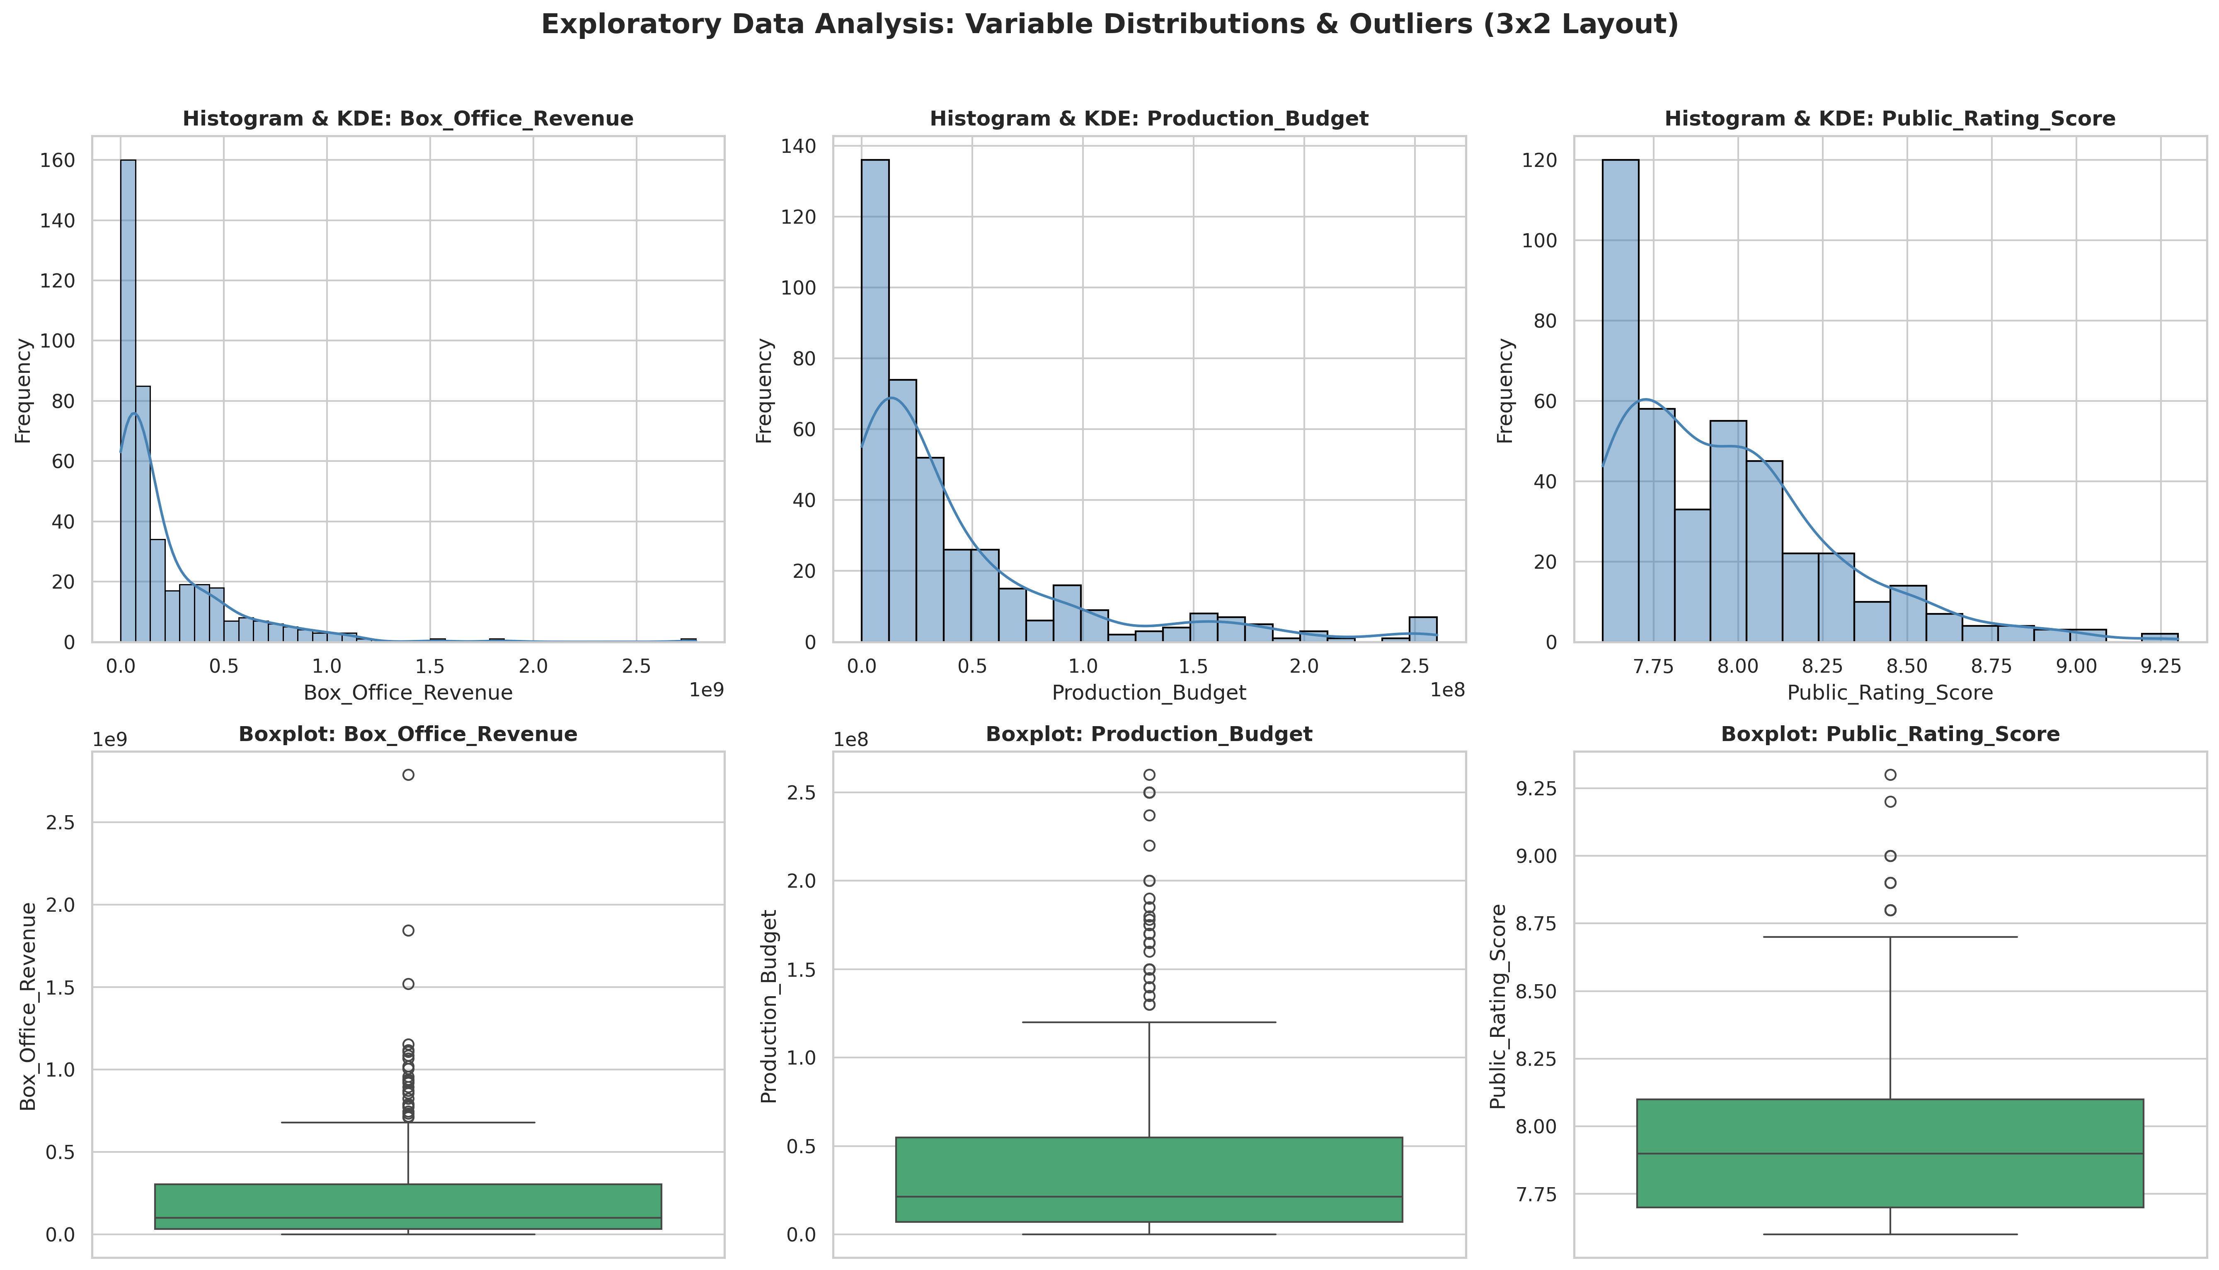
Distribution & Boxplot Characteristics (EDA Findings): Box_Office_Revenue exhibits a right-skewed distribution, with blockbusters forming a long upper tail. Production_Budget also shows a right-skewed distribution, with high-budget productions occupying the upper tail. In contrast, Public_Rating_Score is tightly concentrated around 7.9, with a standard deviation of approximately 0.32. This limited variation may reduce the explanatory power of ratings when used alone to predict box office revenue. The skewness of financial variables supports using logarithmic transformations in subsequent regressions
Task 3: Correlation Analysis and OLS Regression Modeling (Statistical Inquiry)
Calculate the $3×3$ Pearson correlation coefficient matrix and plot a heatmap. Construct three sets of OLS models:
Univariate Model 1: $\log_{10}\left(\text{Box_Office}\right)∼\log_{10}\left(\text{Production_Budget}\right)$
Univariate Model 2: $\log_{10}\left(\text{Box_Office}\right)∼\text{Public_Rating_Score}$
Multiple Regression Model: $\log_{10}\left(\text{Box_Office}\right)∼\log_{10}\left(\text{Production_Budget}\right)+\text{Public_Rating_Score}$
Correlation coefficient：
${\text{Correlation}}_{\text{Box_Office}\text{, }\text{Budget}}$ = 0.771 （Strong positive correlation）
${\text{Correlation}}_{\text{Box_Office}\text{, }\text{Rating}}$ = 0.108 （Very weak positive correlation）
${\text{Correlation}}_{\text{Budget}\text{, }\text{Rating}}$ = -0.017 （Virtually no correlation, indicating low multi-collinearity between predictors）
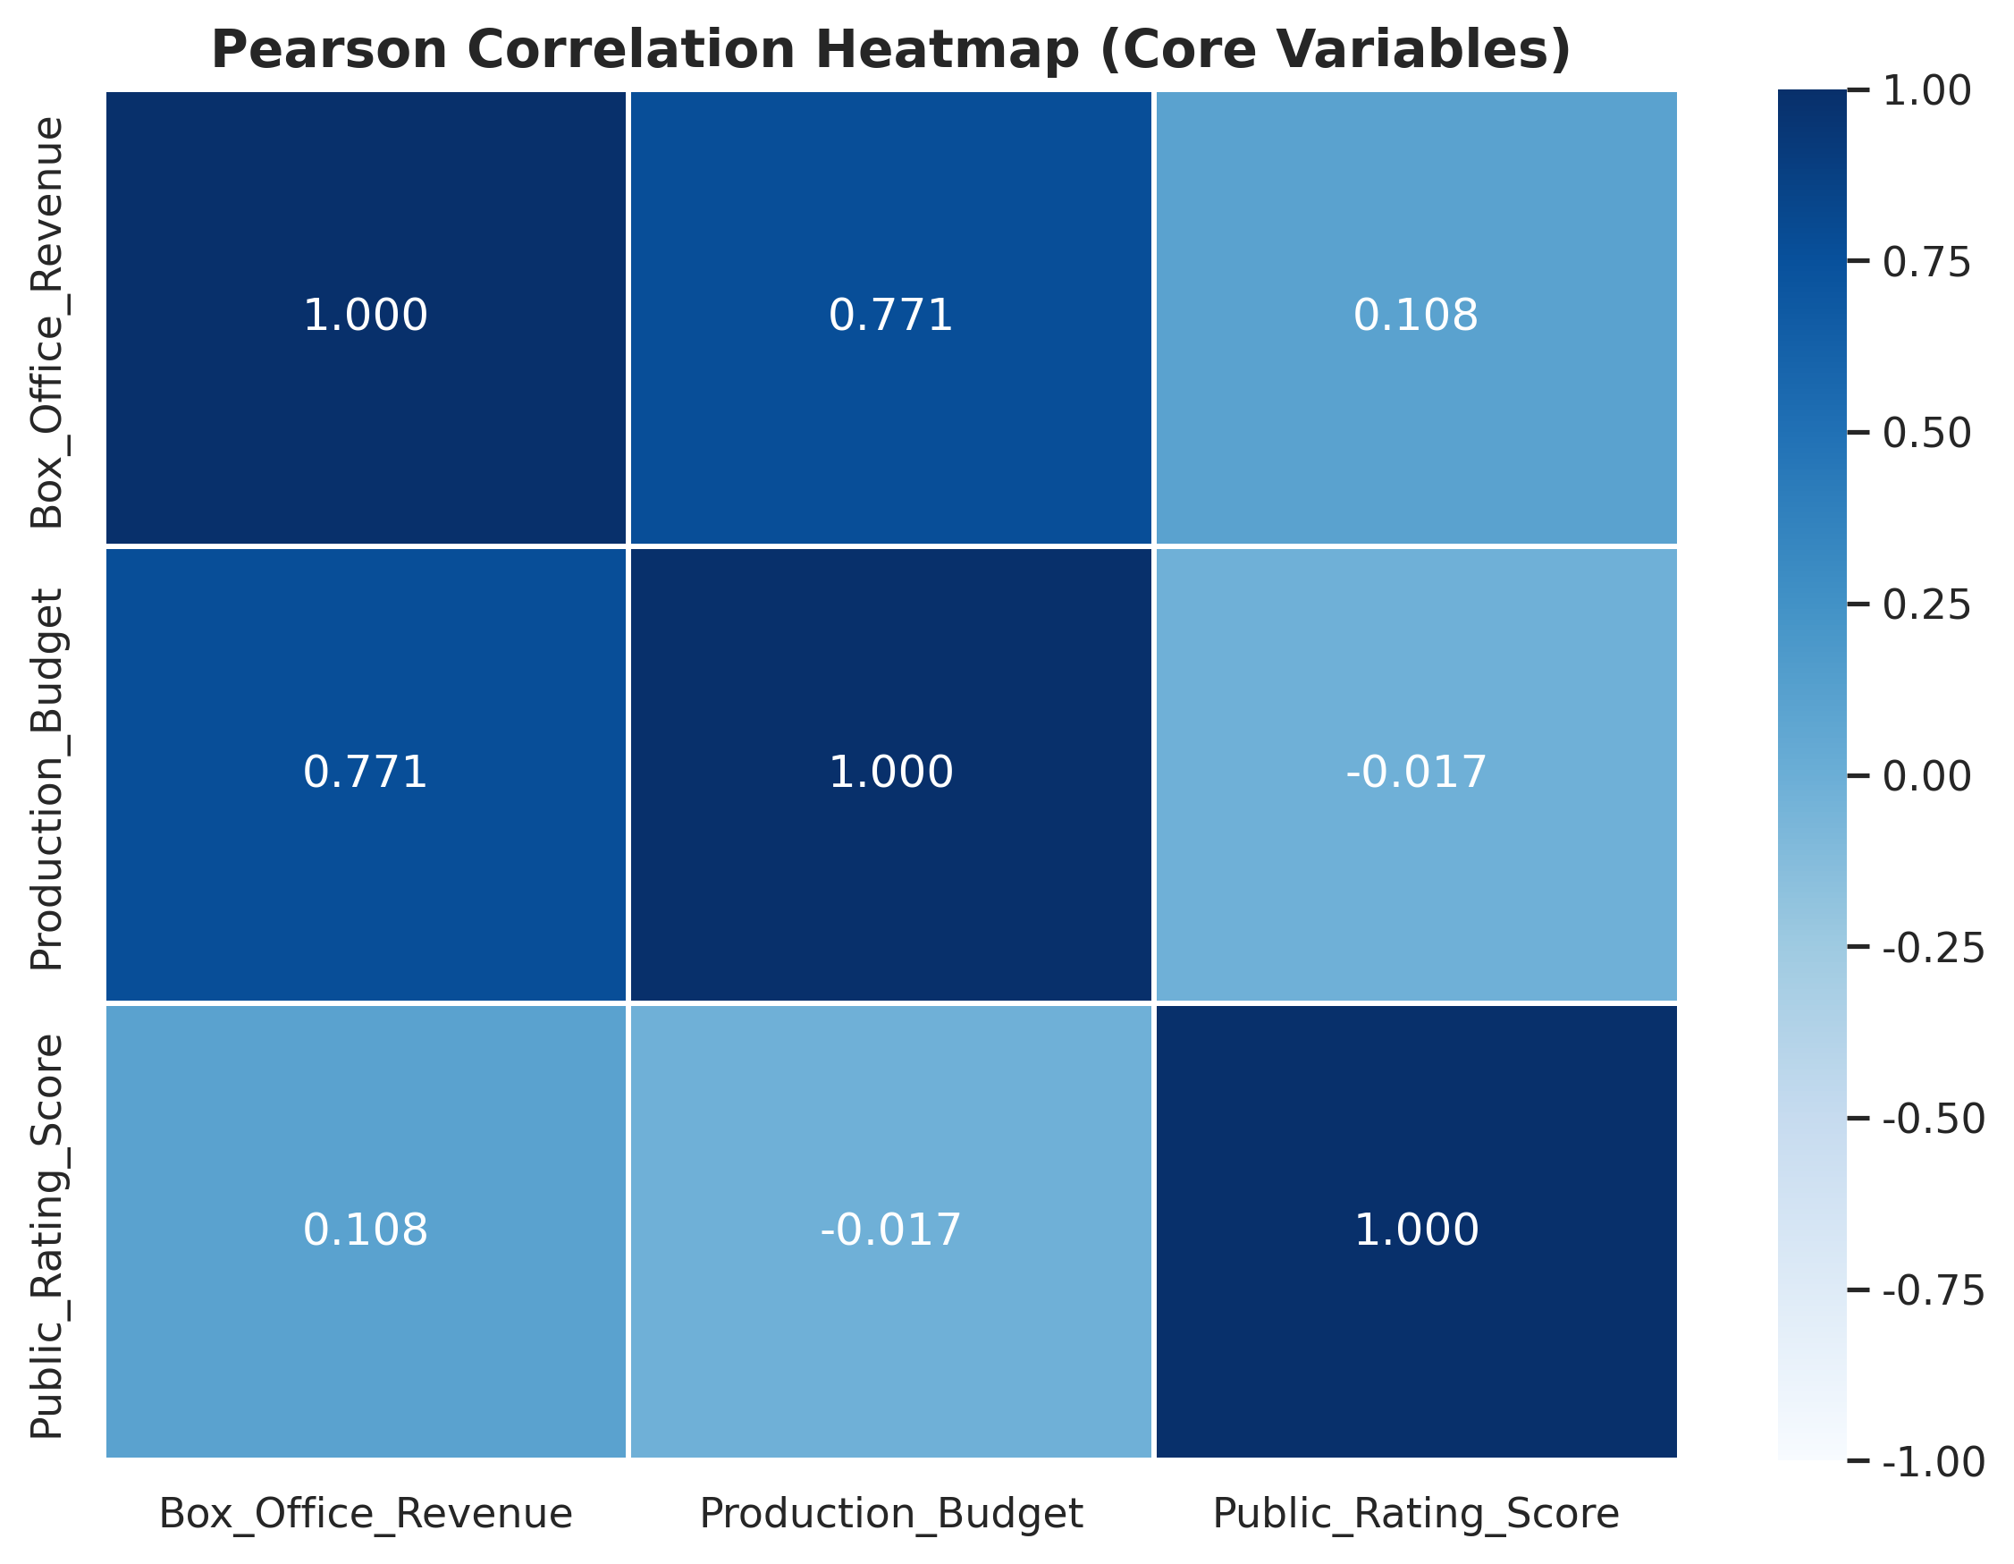
Model Comparison Table:
Model | Intercept | Coef (Log Budget) | Coef (Rating) | R-squared | Adj R-squared
Log Budget | 3.688 | 0.588 | — | 0.416 | 0.414
Rating | 7.375 | — | 0.072 | 0.001 | -0.001
Budget + Rating | 2.127 | 0.594 | 0.190 | 0.424 | 0.421
Task 4: Visualization Rendering and Analysis Report Writing (Visualization & Reporting)
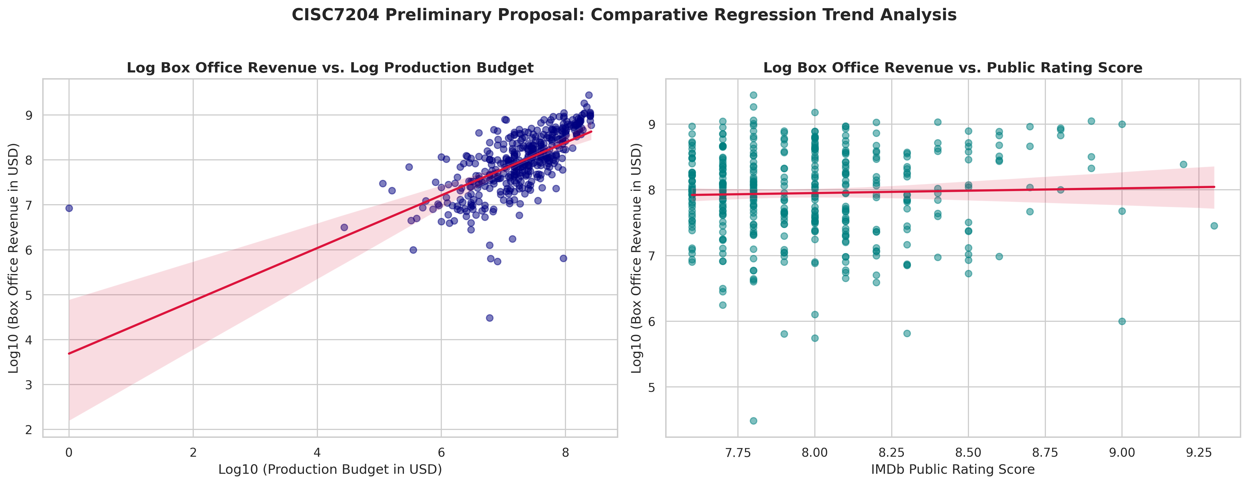
Explanatory Power of Single Predictors: In the fitted sample, the budget-only model achieves an $R^{2}$ of 0.416, substantially outperforming the rating-only model ($R^{2}$ = 0.001). This indicates that log-transformed production budget explains a much larger share of revenue variance than public ratings alone. However, statistical significance must be evaluated via estimated coefficients and p-values, rather than inferred from $R^{2}$ alone.
Joint Effects & Coefficient Squeezing: Adding public rating to the budget model increases $R^{2}$ from 0.416 to 0.424 (adjusted $R^{2}$ from 0.414 to 0.421). The budget coefficient remains stable (0.588 to 0.594), while the rating coefficient shifts from 0.072 to 0.1895. This suggests public ratings provide incremental explanatory value after controlling for budget, though statistical significance must be confirmed via coefficient estimates and p-values rather than $R^{2}$ alone.
Trend Visualization & Policy Implications: Scatter plots show a steep, upward fit for budget versus revenue compared to a flat trend line for ratings. This indicates high ratings alone cannot compensate for under-capitalized production. Commercial success depends fundamentally on capital scale, with ratings serving as an incremental multiplier.

Criteria for Success
Deliverables are assessed against two primary criteria: Data Merging Quality, requiring successful cleaning, title-matching, and retaining complete records for over 400 films without missing financial or rating indicators; and Statistical Rigor, demanding standardized OLS models that clearly report p-values, r, $R^{2}$, and adjusted$R^{2}$ to address the research questions.

Collaboration Issues
Luo Yawen (mc656094): Co-managed project planning and task execution; took charge of dataset acquisition, research design, Python data cleaning, and EDA; contributed to regression modeling, visualization, drafting all sections, document formatting, and final proofreading.
Xu Yiting (mc652844): Co-managed technical validation and pipeline design; took part in research hypothesis framing and code structure optimization; contributed to regression modeling, visualization, statistical interpretation, drafting report sections, model verification, and text polishing.

